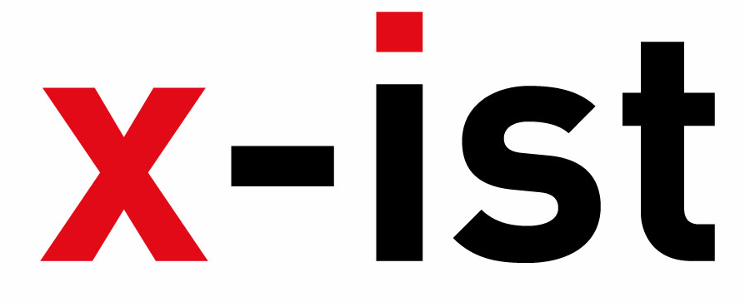 | Abdi İpekçi Caddesi, Kaşıkçıoğlu Apt. No:42 D:2 34365, Nişantaşı, İstanbul  www.artxist.com info@artxist.com  T. +90 212 291 77 84 F. +90 212 343 69 35 | PRESS RELEASE

Ceren Oykut @ Artissima (Italy)

Site-specific solo show of Ceren Oykut titled "What Is My Name?"
will be at the Present / Future Section of ARTISSIMA, Torino between November 8 - 10, 2013.

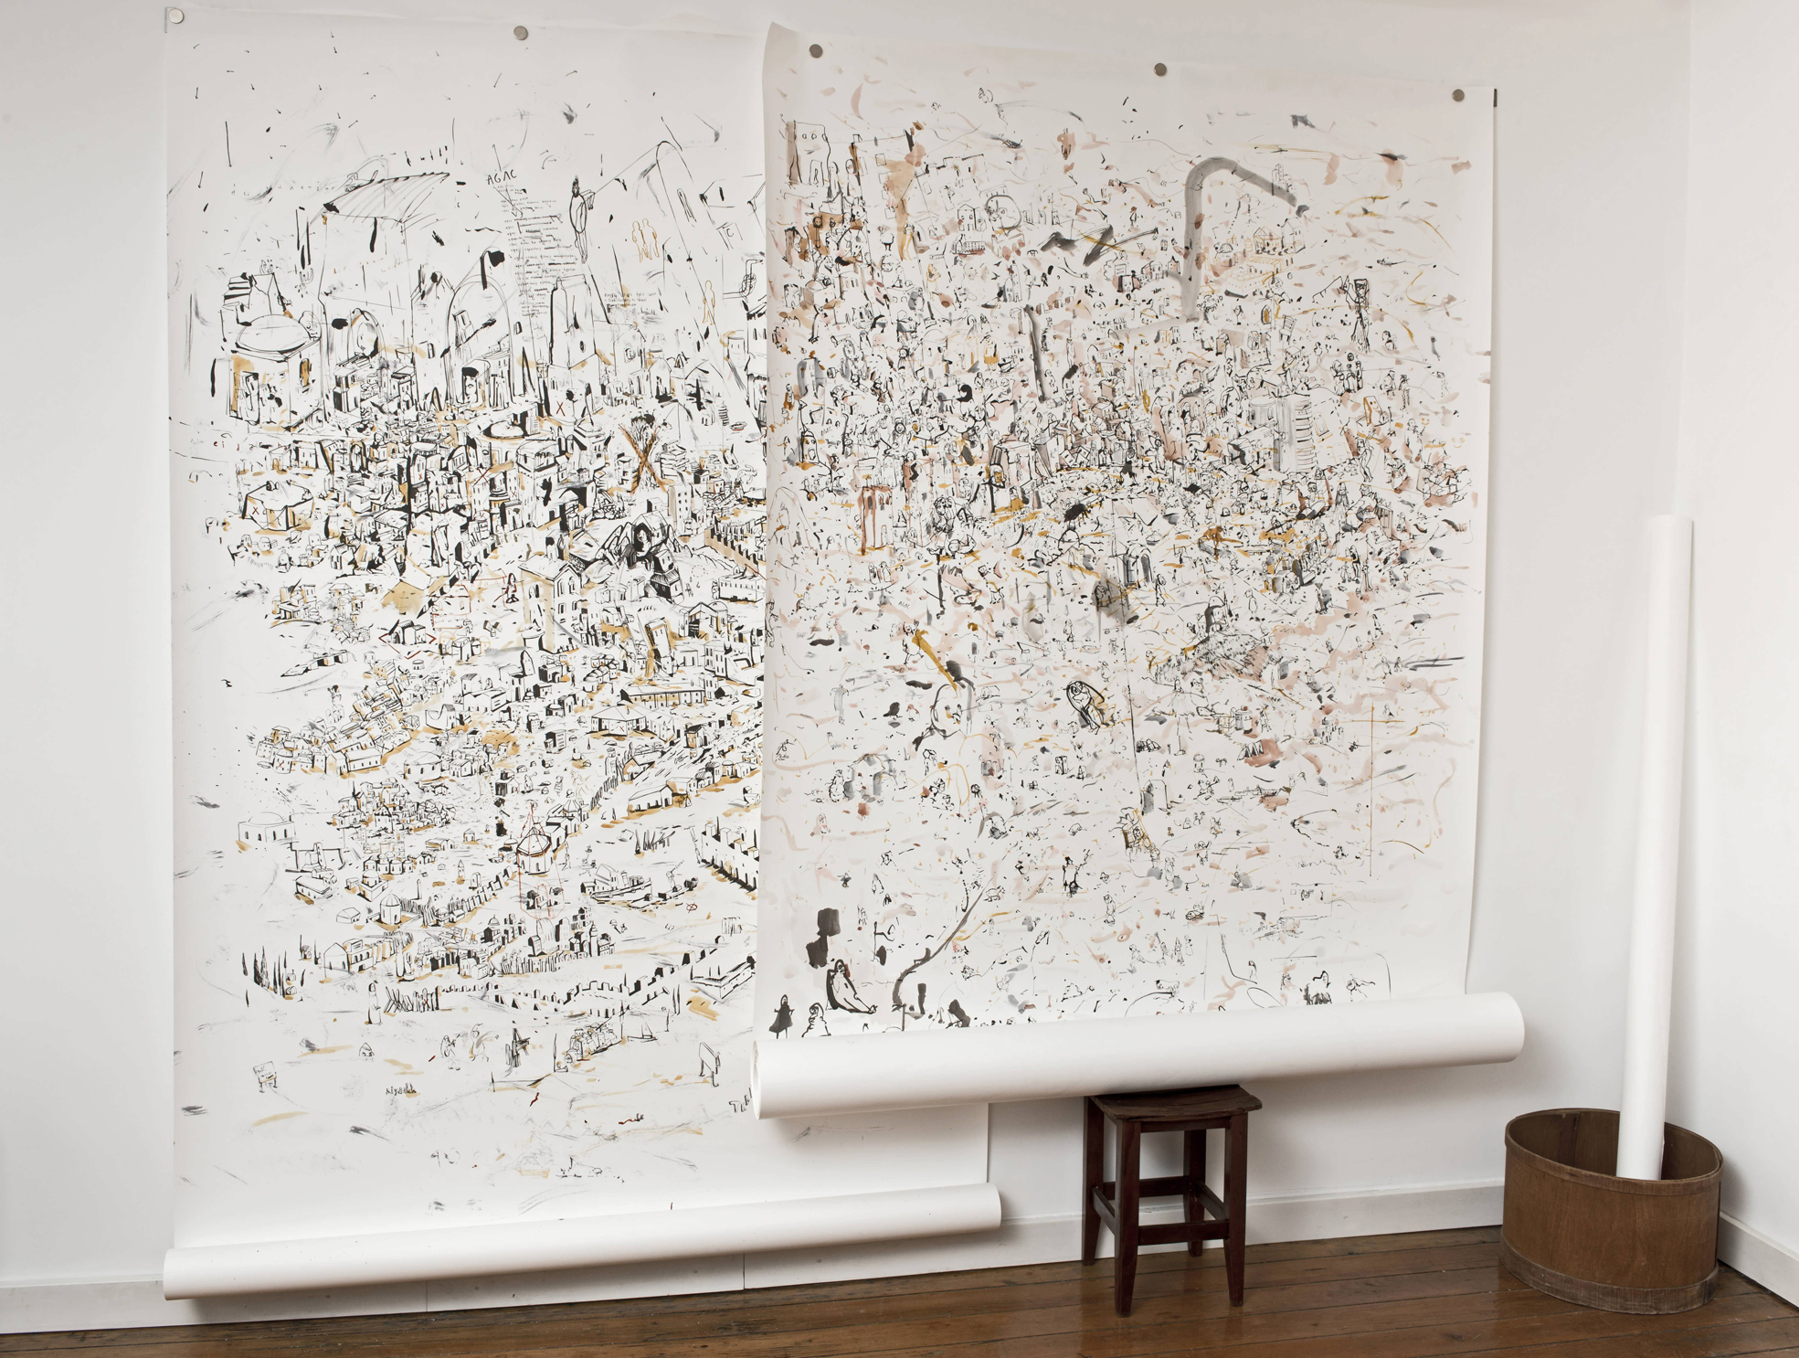

Ceren Oykut, “What Is My Name”, Studio installation view, 2013

Present / Future has been a launch pad for talented young artists and a highly significant platform for new visions and approaches for thirteen years. A group of emerging artists including Ceren Oykut, have been selected by a team of young curators and will be presented by their galleries in the Present / Future exhibition area of Artissima. During the fair a jury of international curators and museum directors including Defne Ayas (Witte De With Center of Contemporary Art, Rotterdam), Matthew Higgs (White Columns, New York), Beatrice Merz (Castello di Rivoli Museum of Contemporary Art, Rivoli) and Joanna Mytkowska (Museum of Modern Art, Warsaw) will award the “illy Present / Future” prize to the artist exhibiting the most remarkable project. Since 2012, the award consists in the production of an exhibition by the winning artist/s in the Castello di Rivoli Museum of Contemporary Art.

Ceren Oykut, one of the most exquisite drawers in Turkey, brings together painting and cartoon in her work where she combines her personal memories with everyday scenes from the city. These meticulously drawn black and white miniatures reflect her subconscious while reconstructing social events and contain symbols that refer to the urban life as well as the artist herself. Her work have been shown in many exhibitions in Turkey, Germany, Italy, Slovenia, France, Poland, Austria, Ireland, Belgium, Egypt including Lyon Biennale (2009) and Istanbul Biennale (2007).

Artist Biography

CEREN OYKUT
Istanbul, 1978

After graduating from Mimar Sinan University, Fine Arts Faculty, Painting Department in 2002, Ceren Oykut had her first solo show in 2003 “Drawing Exhibition” in Kultur Köln 30, Germany. Oykut’s other solo shows are: “Utopia” (Karaburun Festival, İzmir, 2005), "City Can" (Under Construction Contemporary Art Space, Maltepe, İstanbul, 2006), "City Can" (Under Construction Contemporary Art Space - Kuştepe Branch, Kuştepe, İstanbul, 2006), "Musical Drawings" (Karaburun Festival, İzmir, 2006), "Lost Passport” (Kibla, Maribor, Slovenia, 2008), "Original / No Subtitles" (artSümer, İstanbul, 2010), “With Bells On" (artSümer, İstanbul, 2011) and “Indistinct” (x-ist, 2013). Among the national and international exhibitions, biennials and fairs she participated in are: "Postcards from Stockholm / Istanbul" (Botkyrka Konsthall, Stockholm, Sweden, 2006), "Hafriyat Group Exhibition" (Hafriyat Karaköy, 2007), "Save As.. Contemporary Art From Turkey" (Triennale Bovisa, Milano, İtaly, 2008), "Tracing" (Kasa Gallery, 2009), "Istanbul Traverseé" (Palais Des Beaux Arts De Lille, France, 2009), “Reciprocal Visit” (DEPO, İstanbul, 2009), 10th Istanbul Biennial ("2+1", santralistanbul, 2007), Lyon Biennial 2009 ("La Spectacle du Quotidien", Musee d’Art Contemporain de Lyon, France) and “Journeys. Wanderings in contemporary Turkey” (Espace Culturel Louis Vuitton, Paris, 2012). Invited by Lille 3000 for "I Dream But.." and "İstanbul Traverseé" exhibitions she attended a residency program in France. The artist also took place in Contemporary Istanbul 12 & 13, Scope Basel 12, Arco Madrid 2013 and Art Basel Hong Kong 13 fairs. Oykut contributes to several periodic publications such as Radikal Kitap, Bant Magazine. Ceren Oykut is featured in the book “Unleashed: Contemporary Art From Turkey” first published in 2010.

